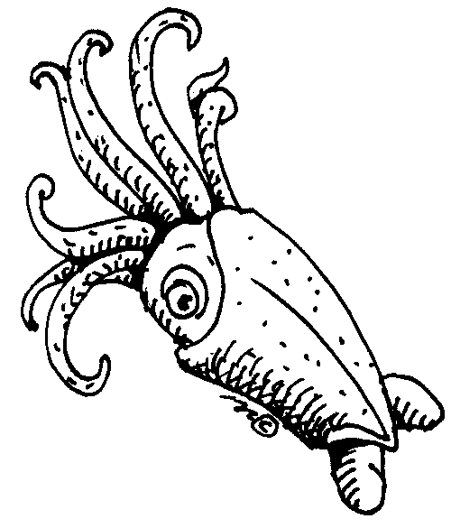

Marine Feature Article Checklist

Marine reporters, you have been assigned a research topic by the Editor of The Ocean. The Ocean is an important marine biology magazine that appears monthly. It is your job to make the next issue, the 500th in print, a special one to remember.

Be sure to include the following in your article:

- Always reports facts, realistic ideas, or real events.
- Include have headings that divide the article into sections.
- May repeat or quote what an expert says.
- Include photographs, graphs, or other visuals with captions.
- May tell the meaning of words that pertain to that subject.
- Needs a “Catchy” title to catch the reader’s attention.
- Needs a “Grabber” paragraph to grab the interest of the reader.
- Needs information that is factual, but not boring.
- Needs a “wrap-up” paragraph that brings the article to a nice close.

